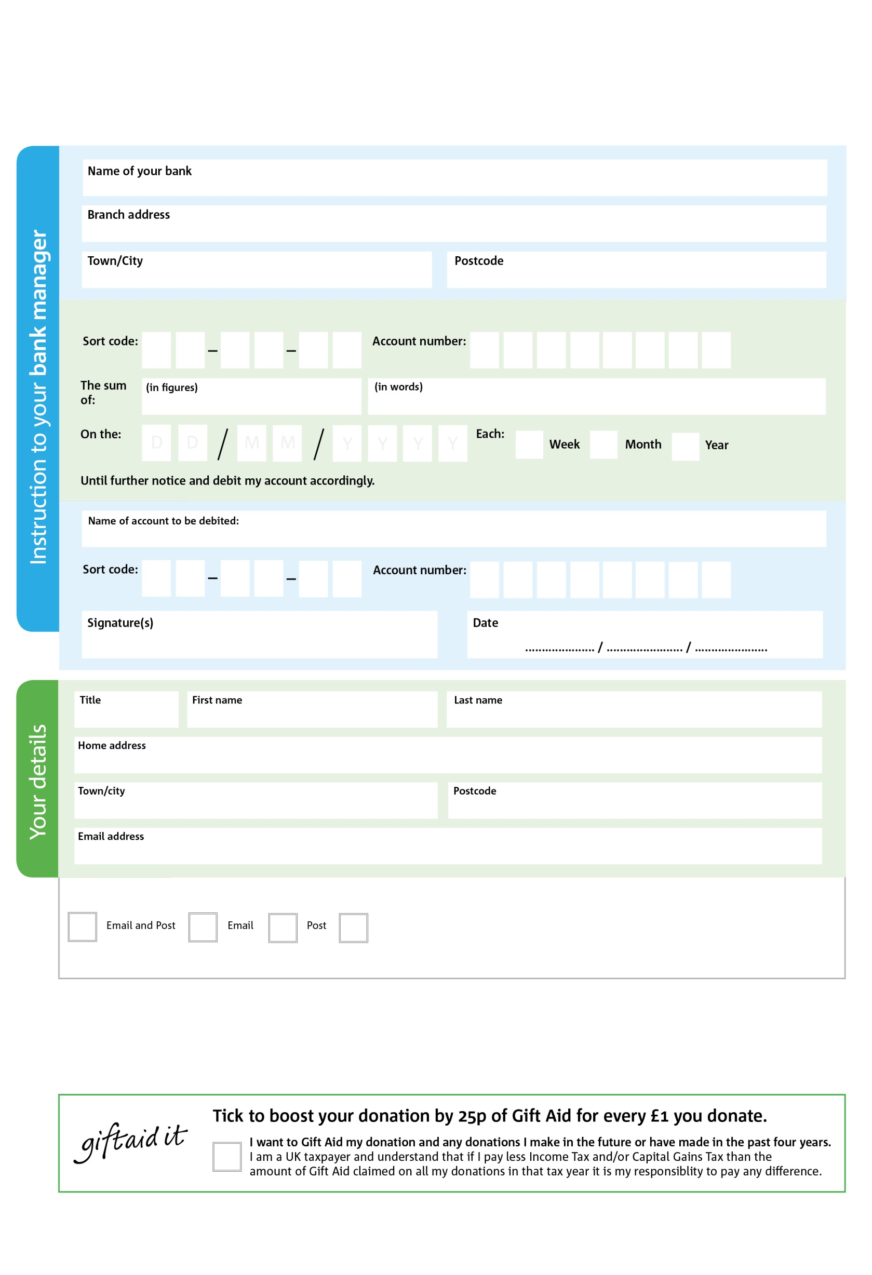

Reg. Charity No: 1185491 | Reg. in England & Wales

You can change your preferences any time by contacting us on 01273 239999 or emailing us at jon@stmatthiasbrighton.org

Please pay Hollingdean Foodbank, C/O St Matthias Church

POSTAL ADDRESS: Hollingdean Foodbank, 360C Ditchling Road, Brighton, East Sussex BN1 6JQ

3

V

2

V

6

V

9

V

7

V

3

V

1

V

9

V

**Please pass this form onto the foodbank, using the foodbank’s address at the bottom, who will save a copy for their records.   
They will then send it onto your named bank or building society.**

1

0

4

14

0

4

We would love to keep you up to date with information about Hollingdean Foodbank. Please tick your preference:

I do not wish to receive future communications from Hollingdean Foodbank

**Data protection**

*Hollingdean Foodbank is committed to protecting your privacy and will process your personal data in accordance with current Data Protection legislation. Hollingdean Foodbank collects information to keep in touch with you and supply you with information relating to our work. To unsubscribe from our newsletter, send a message to the email address above with the word unsubscribe in the subject line. A full data privacy statement for financial donors is available from the foodbank on request.*

**Standing Order Mandate**

**hollingdean.foodbank.org.uk**

You can change your preferences any time by contacting us on XXXXXXXXXXX or emailing us at XXXX@XXXXXXXXXX.foodbank.org.uk

I do not wish to receive future communications from XXXXXX Foodbank